**Chapter 6: Field Effect Transistors (FET)**

Table of Contents

6.2 Construction and Characteristics of JFETs 3

6.3 Transfer Characteristics 5

6.7 Depletion-Type MOSFET 6

6.8 Enhancement-Type MOSFET 8

The FET is a three terminal device that is in many ways similar to a BJT, but is controlled by voltage as opposed to current. This means that, while the output current $I_{C}$ was dependant on the input current $I_{B}$ for a BJT, the output current is dependant on the input voltage for an FET.

Like BJTs have npn and pnp bipolar transistors, FETs also have n-channel and p-channel types, but unlike BJTs, FETs are unipolar, meaning the device depends solely on electron or hole conduction.

Similar to how permanent magnets manipulate the movement of magnetic materials by creating a magnetic field, FETs create an electric field, allowing them to control the conduction path of the output circuit without being in direct contact with it.

We will be looking into two types of FETs, Junction Field Effect Transistors (JFETs) and Metal Oxide Semiconductor Field Effect Transistors (MOSFETs). MOSFETs can be further broken down into a D-Type and an E-Type. We will be looking into these as well.

## 6.2 Construction and Characteristics of JFETs

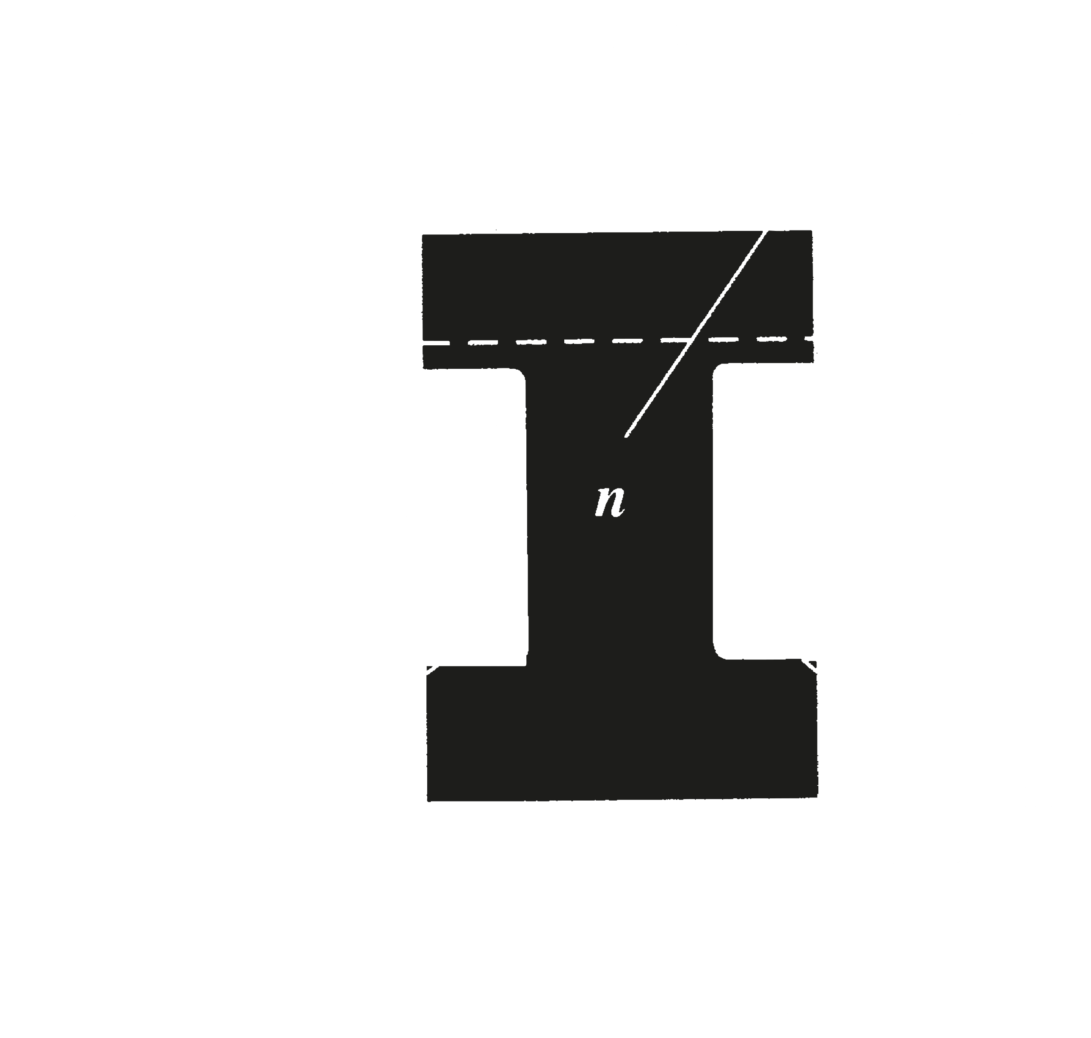

The JFET has three terminals, with one terminal (the Gate) being able to control the current between the other two. In the absence of any applied potential, the JFET essentially has two p-n junctions under no-bias conditions. This results in a depletion region at each junction.

At $V_{GS}=0$, we connect the gate directly to the source. We also set up some positive voltage $V_{DS}$. Electrons are drawn to the drain terminal, setting up a current $I_{D}$.



Notice that we have set up a reverse bias in this way. From bottom to top, the potential difference from $S$ is increasing. The higher the potential, the greater the reverse bias, and the wider the depletion zone. Thus, we end up with a curved depletion zone with the zone getting wider as we get closer to $D$.

As we increase the voltage $V_{DS}$, the resulting current $I_{D}$ will also increase. However, at some point, it will flatten out. The saturation point has been reached. This happens because as we increase $V_{DS}$, the depletion zone towards the top also gets narrower, which increases resistance to the flow of $I_{D}$. The resistance and flow of current fight each other as voltage keeps increasing, keeping the current constant. This constant current is denoted by $I_{DSS}$, the maximum drain current. The voltage at which this current is established is called the pinch-off voltage, $V_{P}$. If we keep increasing voltage beyond $V_{P}$, the depletion zone evens out along the length of the p-terminals.



For $V_{GS}<0$,the p-terminals become reverse biased. This will cause the same effects as we saw earlier, but the saturation level will be reached for a lower level of $V_{DS}$.

For $V_{GS}>0$, the p-terminals become forward biased, but the system is still reverse biased, so the overall effect will not change, but will be reached at a slower rate. If we keep increasing $V_{GS}$, it would overcome $V_{DS}$ and make the system forward biased, but this effect can be nullified by increasing $V_{DS}$.

## 6.3 Transfer Characteristics

For JFETs, the relationship between $I_{D}$ and $V_{GS}$ is given by Shockley’s equation:

$$I_{D}=I_{DSS}{\left(1-\frac{V_{GS}}{V_{P}}\right)}^{2}$$

This gives us a transfer curve, which we can plot directly next to the characteristics curve of a the JFET like this:

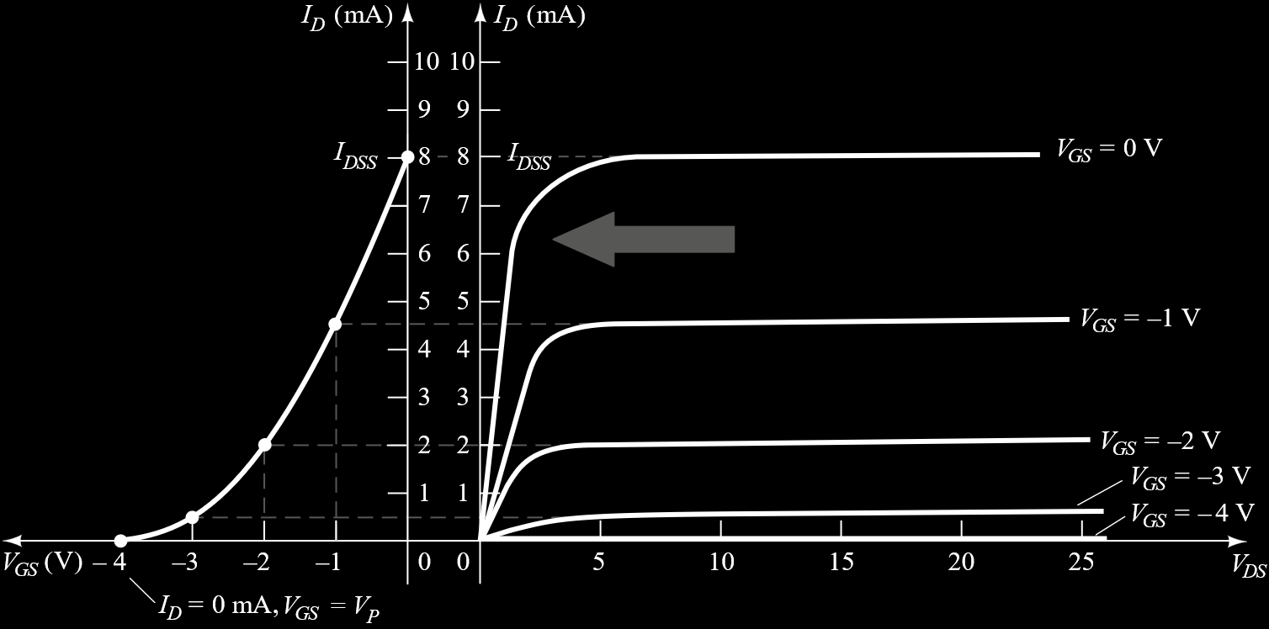

## 6.7 Depletion-Type MOSFET

A n-channel D-Type MOSFET consists of a slab of p-type material (the substrate) with a channel of n-type material connecting the source and drain. In some cases, the p-type material is internally connected to the source, but in many, like here, it is connected through a separate terminal (labelled SS).



The gate is separated from the n-channel by a thin SiO2 layer. SiO­2 is an insulator, known as a dielectric. So, there is no direct electrical connection between the gate and the channel of a MOSFET.

Let us now apply some voltage $V_{DD}$ across the drain to source terminals and look at what happens for different conditions of $V_{GS}$.



For $V_{GS}=0$, the device reacts in exactly the same manner as a JFET, giving us a saturation level as we increase $V_{DD}$.

For $V_{GS}>0$, the majority carriers in the p-type material are repelled, while the minority electrons begin to form layers on the side of the existing n-type channel. This increases the width of the n-channel, which results in a higher value of $I_{D}$.

For $V_{GS}<0$, the opposite happens, making the channel narrower and causing $I_{D}$ to drop.

Shockley’s equation continues to be applicable here, giving us graphs like this:



## 6.8 Enhancement-Type MOSFET

An E-Type MOSFET is exactly the same as a D-Type MOSFET, except that it does not have a channel at all.



This means, once a voltage $V_{DD}$ is applies, for the condition $V_{GS}=0$, absolutely nothing happens. There is no current $I_{D}$.

For $V_{GS}>0$ however, the electrons in the p-type material are attracted to the left side of the slab. They do no pass into the gate due to the SiO2 layer. As we increase $V_{GS}$, they slowly begin to join the two n-type regions, creating a channel. This channel allows a current $I_{D}$ to pass. The voltage at which a measurable current begins to flow is called the threshold voltage $V_{T}$. Below this, current is basically $0$. If we hold $V_{GS}$ constant after this point and increase $V_{DS}$, we will eventually reach a saturation point just as we did for JFETs and D-Type MOSFETs, reaching a pinch-off point.

$$I_{D}=k{\left(V_{GS}-V_{T}\right)}^{2}$$

For $V_{GS}<0$, the opposite happens, with electrons being pushed to the right side, which again causes no current flow since a channel does not exist.

